5.1 Combining Functions
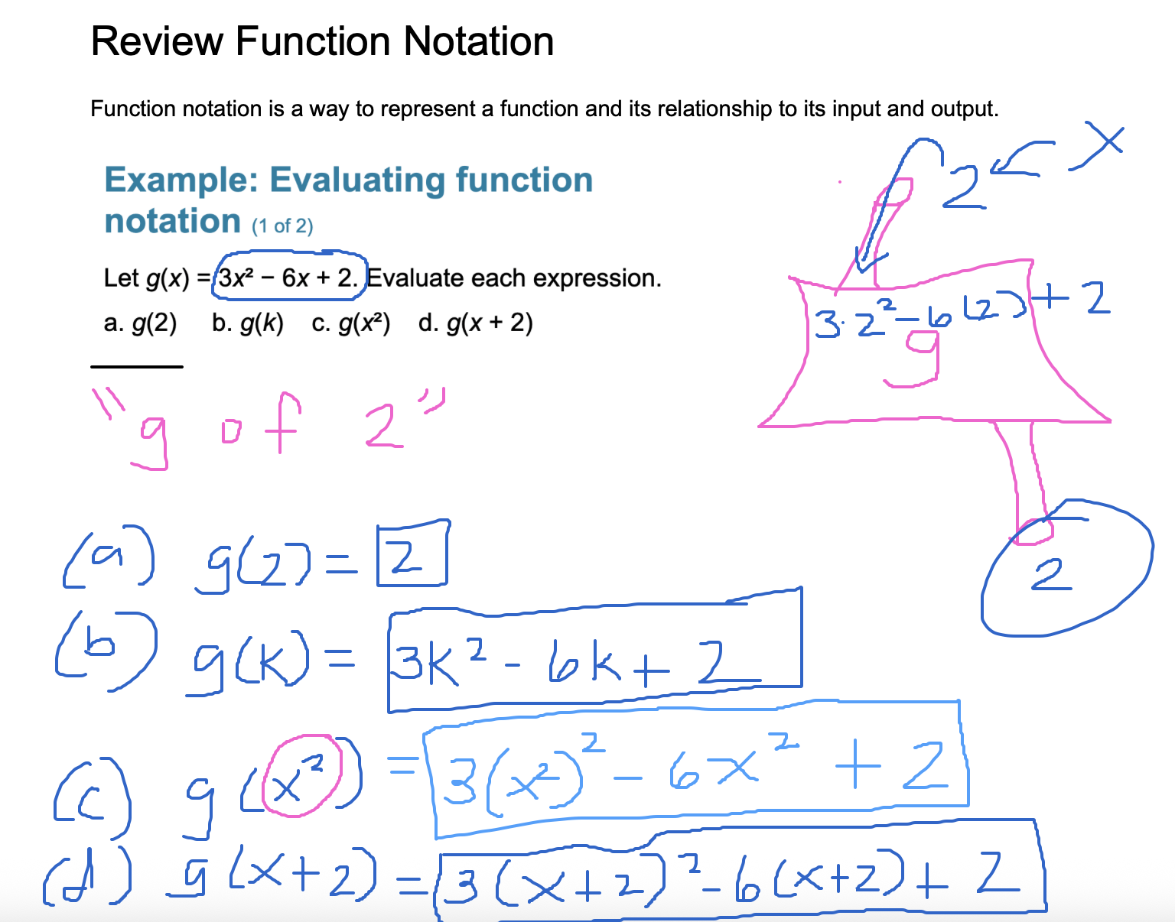

Perform Arithmetic Operations on Functions
We can perform various arithmetic operations on functions just as we would with numbers. These operations include addition, subtraction, multiplication, and division.
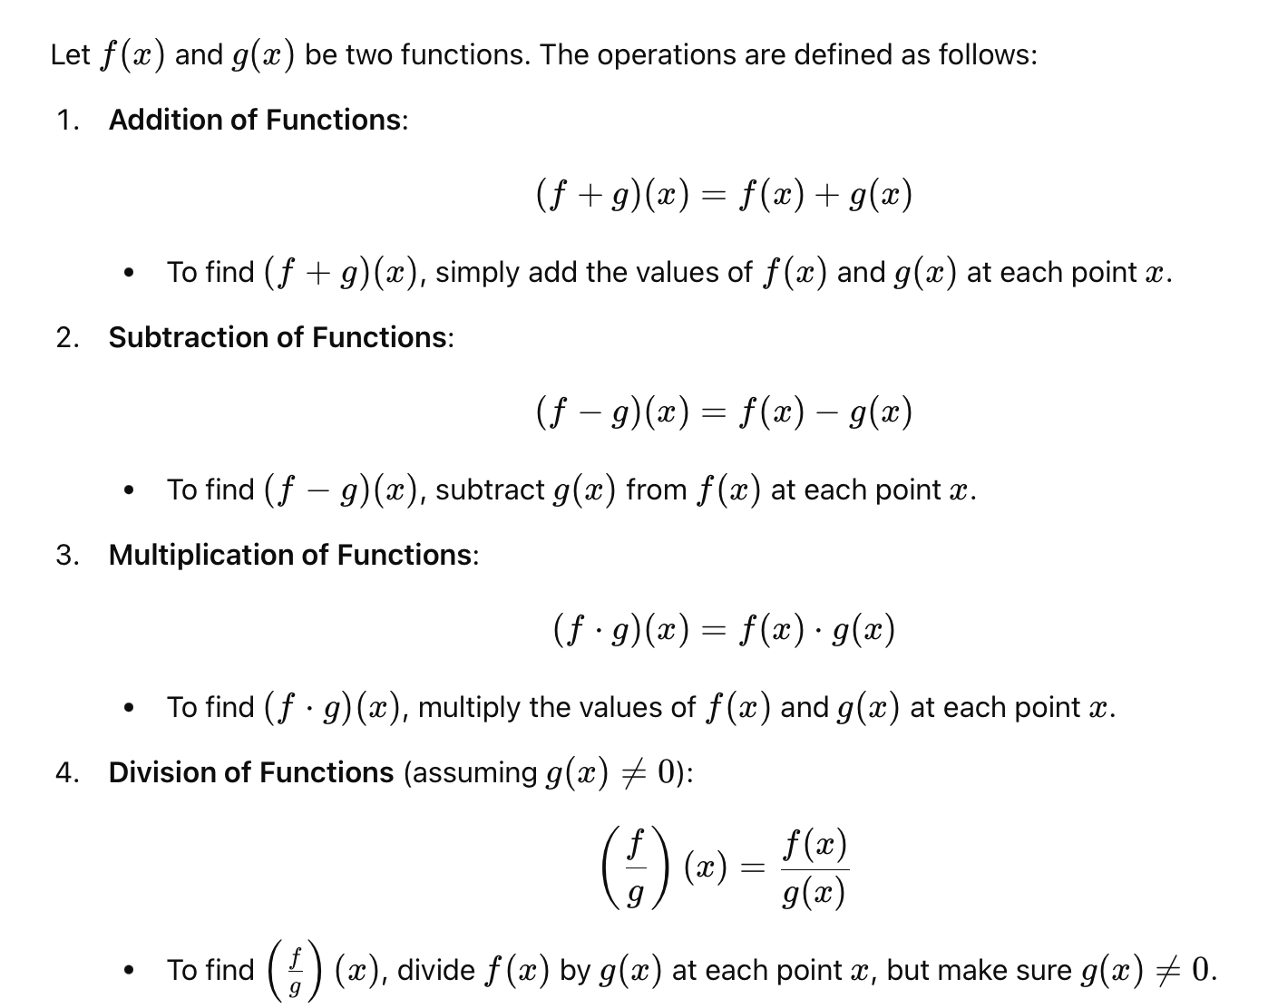
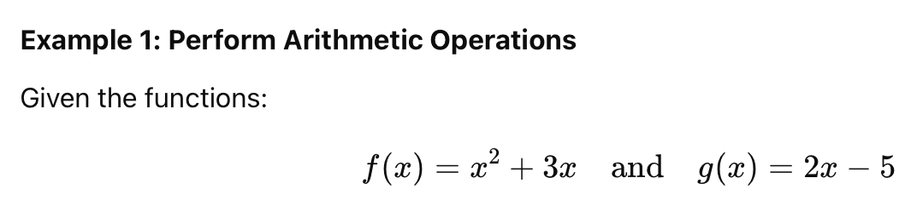
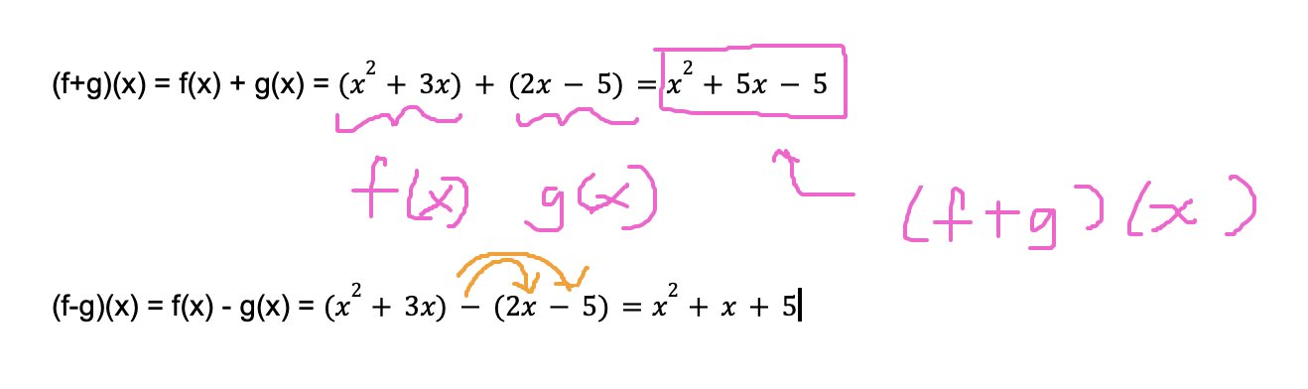

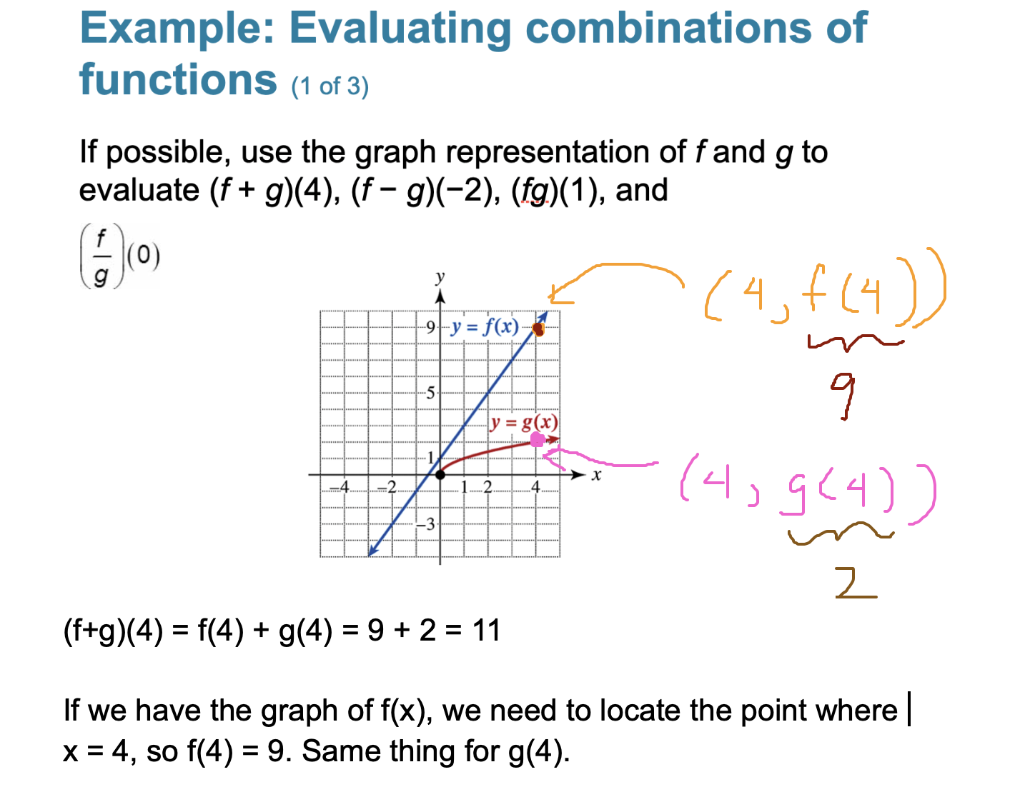

(f-g)(-2) = f(-2) - g(-2) = -3 - ? ------> g(-2) is undefined.
(f-g)(-2) is undefined

(fg)(1) = f(1)g(1) = (3)(1) = 3
(f/g)(0) = f(0) / g(0) = 1 / 0 (f/g)(0) is undefined

Review

f(x) = 3x + 7 and $g(x)=\sqrt{x+1}$

(f+g)(8) = f(8) + g(8) = 31 + 3 = 34
f(8) = 3(8) + 7 = 31, $g(8) = \sqrt{8+1}=3$

Perform Composition of Functions
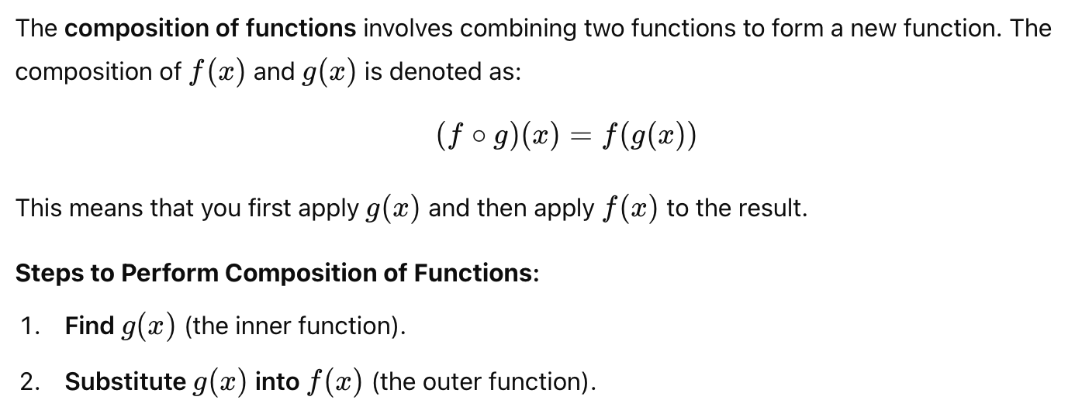
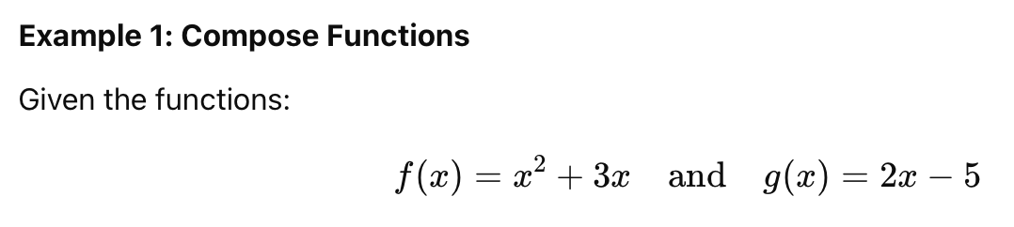

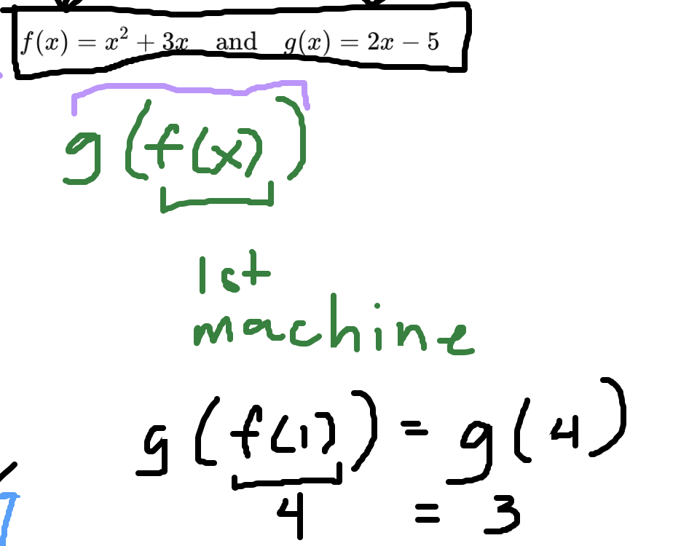 g(f(1)) = g(4) = 3

f(g(1)) = f(-3) = $(-3)^{2}+3(-3) = 9 + (-9) = 0$
g(1) = 2(1) - 5 = -3

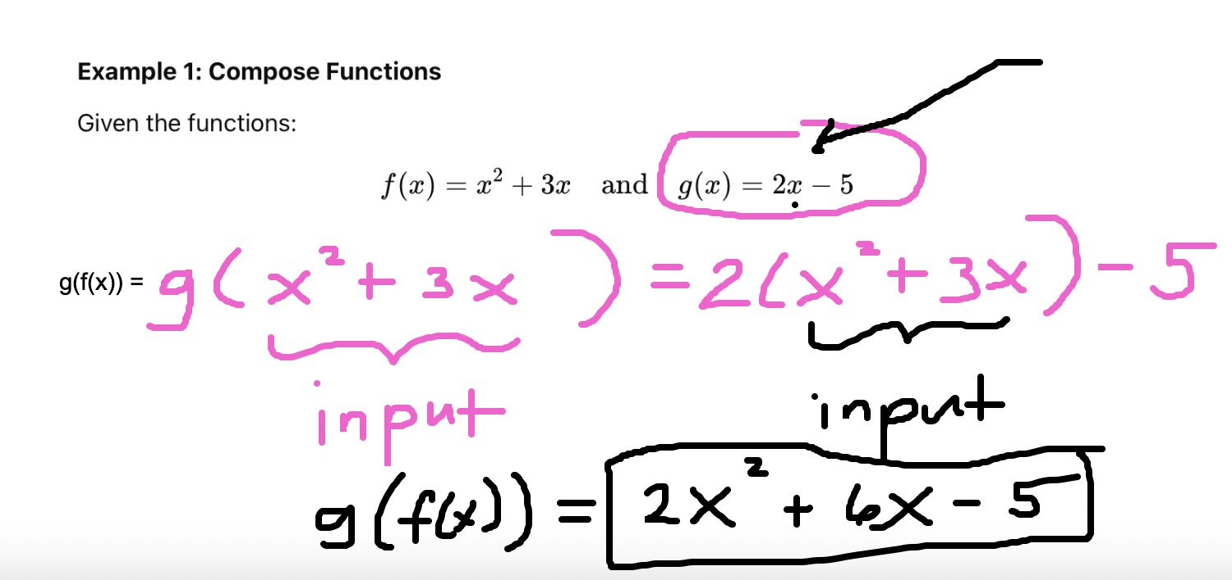

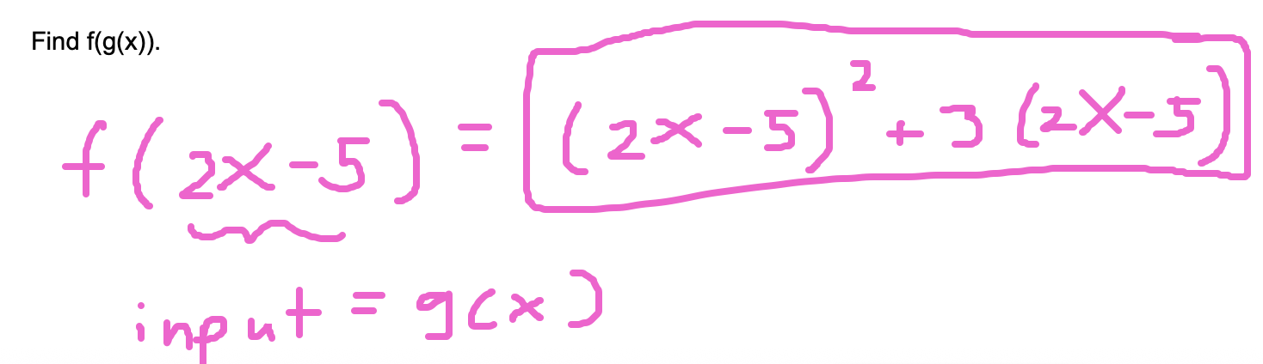

In general, f(g(x)) is not the same as g(f(x)).

